Tribal Interiors LTD

There are five pages that needs to be created, first this is what I want the top of the page to look like:

/Users/Jansher/Desktop/Screenshot 2020-03-04 at 14.07.42.png

This is how I want the page to look when we go on the website; Below This You can write in a block or something “Tribal Interiors Management”. Below is an Example of how I want the page to look like:

Where it Says ComputerGurus, I want it to “Tribal Interiors”. Underneath it will say Tribal Interiors Management Application.

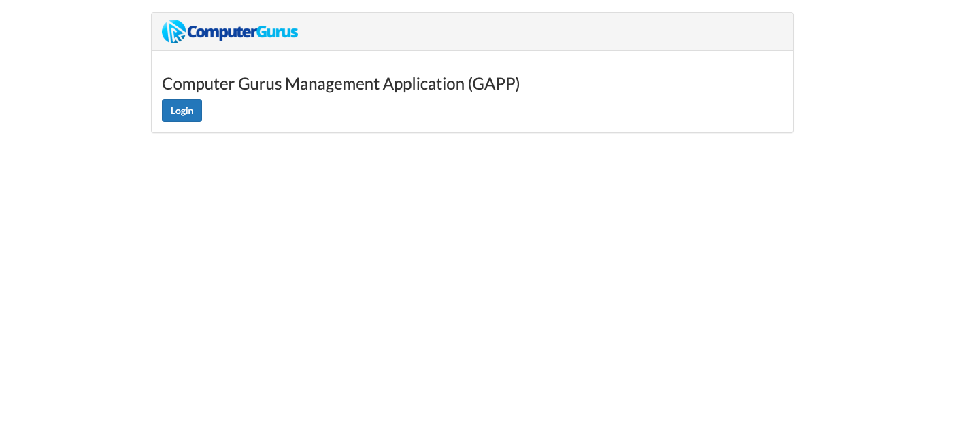

This how the first page should look like. If possible I would like a picture behind it of a Carpet which I will send to you later. 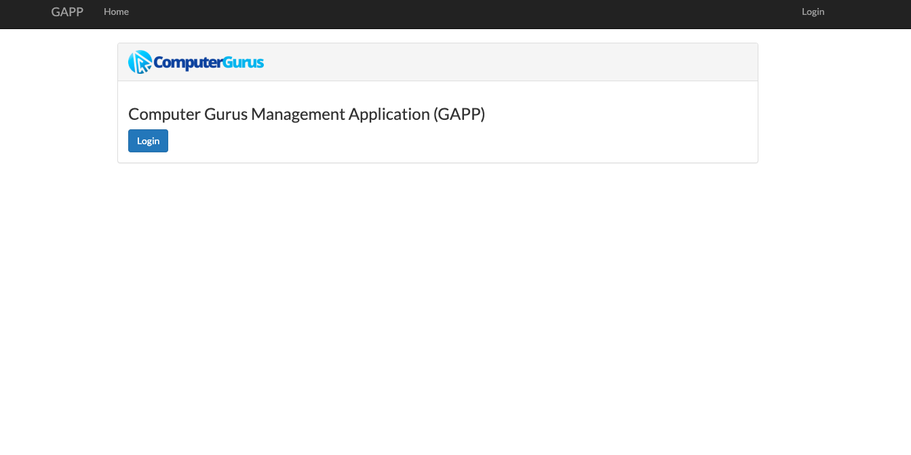

Once the user Login This is how I want the first page to look Like; if there are appointments for the day it will show on the Home Page. Clicking on Home or GAPP in my case “Tribal” it will be the same thing. It should take you to this page.

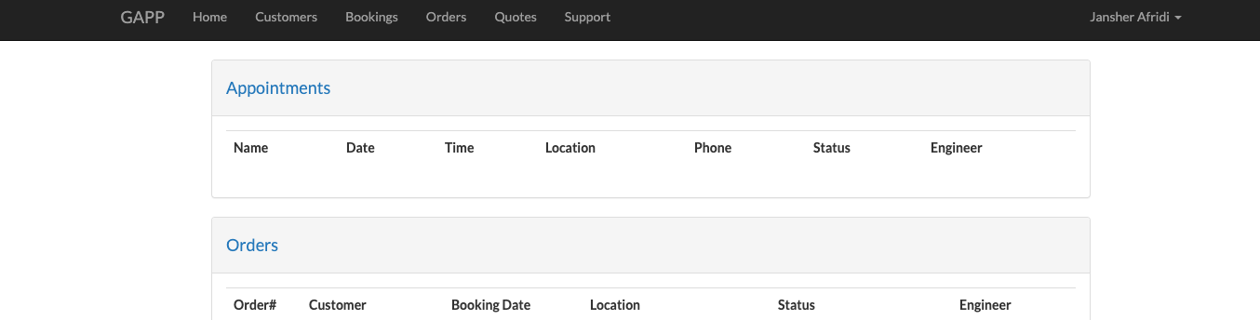

Below is the Customer Page, Customer can be searched by Name, Postocde

